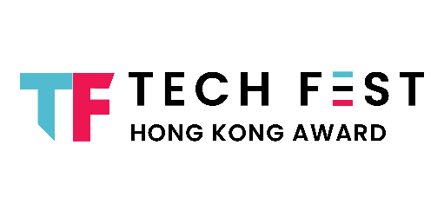
TECH FEST HONG KONG AWARDS 2026

APPLICATION FORM – PERSONAL EXCELLENCE CATEGORY

Notes to Applicants:

- You should submit ONE application for each Award. If you wish to apply multiple awards, please submit them in separate application forms.

- Coverage period for the entry, regardless the completion date, shall fall within the period between 1 January 2025 to 31 December 2025 and the entry shall not be submitted in the following years.

- All parts of the application form shall be completed.

- Application form shall be completed in typewriting in ENGLISH.

- Application form shall be submitted in Word format and file shall be named as following format: [Category_Award_Your Full Name_Organisation (for example: Personal Excellence Category_Chief Technology Officer of the Year_Chan Tai Man_abc company)].

- Equivalent supporting document(s) shall be submitted with a completed and signed application form and sent to awards@revivetech.asia.

- Acknowledgement email will be sent to primary contact person within 7 working days after the submission of application form. Please contact us if no acknowledgement email is received.
Section 1: Award under Personal Excellence Category

Please select ONE of the Awards to participate for:
☐ Chief Information Security Officer of the Year
☐ Cloud Architect of the Year
☐ Chief Digital Officer of the Year
☐ Chief Technology Officer of the Year
☐ Chief Information Officer of the Year
☐ Founder of the Year
☐ Open Source Hero

Section 2: Personal Particulars of Entrant(s)

PRIMARY CONTACT PERSON
Company Name
Name
Job Title
Contact No. | +852
Email Address

SECONDARY CONTACT PERSON (if applicable)
Company Name
Name
Job Title
Contact No. | +852
Email Address

NOMINEE / APPLICANT

Name
Job Title
Company Name
Contact No. | +852
Email Address
Linkedin (if any)
Company Website

Section 3: Particulars of Entry

Key Works Highlights

Description – Maximum 500 words
(please refer to judging criteria)

Section 4: Declarations

- I agree to participate the awards ceremony if selected as awards finalists of Tech Fest Hong Kong Awards 2026.

- I declare that the information and particulars provided on this application form are accurate and complete, and the submitting entry conforms to all general eligibility requirements, terms and conditions and privacy policy.

- I agree to provide relevant information and documentary proof upon request by the Organiser.

- I understand that violation to any eligibility criteria will result in entry disqualification, even if it has already been announced to be a finalist / winning entry, and any awards granted will be withdrawn if it is found otherwise.

- I understand that the Organiser has the right to take following actions against the offending applicants at various stages:

Stage | Action
Eligibility check | Reject entry, with notification to applicants stating the reasons
Adjudication – Assessment, category judging | Disqualification, with notification to applicant stating the reasons
Finalist announced | Withdraw from the finalists list, with notification to applicant stating the reasons
Awards granted | Withdrawal of award and demand return of award/ certificate, with notification to applicant stating the reasons. If award has been announced, publicise the withdrawal case

Signature of Entrant:

_____________________________________________________
Name:
Title:
Company:
Date:

